**Non-woven Fabric Dyeing Process**

**Non-woven fabric dyeing mainly includes two methods: immersion or padding. It involves immersing the fabric in a colored aqueous solution in a dyeing tank, drying it, applying adhesive, and finally drying it again. Alternatively, colored adhesive can be directly applied to the non-woven fabric, followed by drying. The dyeing method provided in this article overcomes the technical problem of non-woven fabrics being difficult to dye. It can meet people's demand for non-woven fabrics of different colors, is environmentally friendly, energy-saving, emission-reducing (zero emissions), reduces the cost of colored non-woven fabrics, and the colored non-woven fabrics produced by this dyeing method are uniform in color, have good color fastness, are not easy to fade, have a soft texture, and do not affect elasticity.**

**1.**    **immersion method**

(1) Unrolling Steps: The non-woven fabric is unrolled using a double-position paper holder.

(2) Dyeing Steps: The unrolled non-woven fabric is pulled through traction rollers to the dyeing tank. The fabric is immersed in the dyeing tank by the traction rollers for dyeing. After dyeing in the dyeing tank, the non-woven fabric is adjusted by curved rollers and excess dye is removed by squeezing rollers.

(3) Drying Steps: The flattened non-woven fabric is dried using a drying machine via curved rollers.

Dyeing Solution Formula

Water-based pigment (Laoan)  1-5%

    Thickener 202A (HY Chemical)    0.1-1%

   Resin 1901 (HY Chemical): 5-20%

Leveling agent: 1-2%

Water: 70-75%

**2.**     **Padding Dyeing Method**

**(1) Unrolling Steps: Unroll the non-woven fabric using a double-position paper holder.**

**(2) Dyeing Steps: The unrolled non-woven fabric is pulled through traction rollers to the dyeing tank. The fabric is immersed in the dyeing tank by the traction rollers for dyeing. After dyeing in the dyeing tank, the non-woven fabric is adjusted by curved rollers, and excess dye is removed by squeezing rollers.**

**(3) Drying Steps: The flattened non-woven fabric is dried using the first drying machine via curved rollers.**

**(4) Gluing Steps: The dried non-woven fabric is treated with adhesive using a gluing machine to fix the color.**

**(5) Drying After Gluing Steps: The paper treated with adhesive is dried using the second drying machine.**

**Dyeing Solution Formula:**

**Water-based pigment (Laoan): 1-5%**

**Leveling agent: 1-2%**

**Water: 95%**

**Gluing Formula:**

**Resin 1901 (HY Chemical): 5-20%**

**Thickener 202A HY Chemical): 1-2%**

**Water: 80-95%**

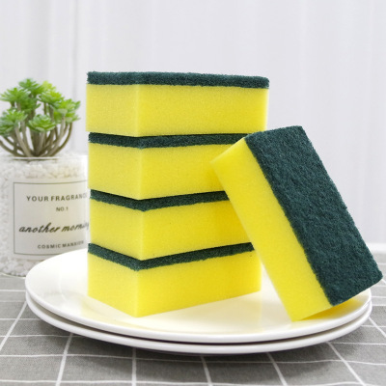

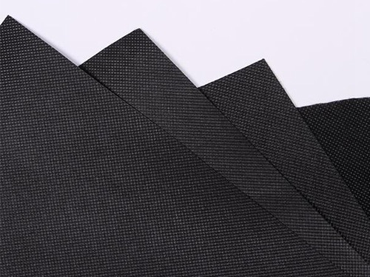

For details, please log in to the official website :www.hy-chemical.cn